**Genome Mining of Monoterpenes from Ascidian-Derived fungus *Diaporthe* sp. SYSU-MS4722**

Siwen Yuan 1ǂ, Shitao Zhuang 2ǂ, Yanhong Han 2, Yuhang Wen1, Senhua Chen 3, Lan Liu 3, Qifeng Lin 3,4, Yan Yan 2,*, Zhizeng Gao 3,* and Qilin Wu 1,*

1 School of Bioengineering, Zunyi Medical University, Zhuhai 519041, China

2 Guangdong Provincial Engineering Research Center, The Fifth Affiliated Hospital, Sun Yat-Sen University, Zhuhai, 519000, Guangdong, China

3 School of Marine Sciences, Sun Yat-sen University, Zhuhai 519082, China

4 Shenzhen Lions King Hi-Tech Co., Ltd, Shenzhen 518000, China

ǂ These authors contributed equally to this work

**\*Corresponding author.** **E-mail**: [wuqilin@zmuzh.edu.cn](mailto:wuqilin@zmuzh.edu.cn) (QLW); [gaozhizeng@mail.sysu.edu.cn](mailto:gaozhizeng@mail.sysu.edu.cn) (ZZG); [yanyan35@mail.sysu.edu.cn](mailto:yanyan35@mail.sysu.edu.cn) (YY)

Contents

**Figure S1**. The predicted biosynthetic pathway of phomoxanthone A in our previous work 4

**Figure S2**. Isolation of monoterpenes from *Diaporthe* sp. SYSU-MS4722 in our previous work 5

**Figure S3**. Gene knockout of *phoE* in *Diaporthe* sp. SYSU-MS4722 in our previous wrok. 5

**Figure S4**. Chiral separation of compounds **2** and **3**.. 5

**Figure S5**. LC-HRMS analysis comparing the production levels of compounds **1**–**3, 7**, and **8** in the wild-type and *phoE* mutant strains 6

**Figure S6**. 1H NMR spectrum for compound **1** (600 MHz, Methanol-*d*4) 6

**Figure S7**. 13C NMR spectrum for compound **1** (150 MHz, Methanol-*d*4) 7

**Figure S8**. HSQC spectrum for compound **1** 7

**Figure S9**. HMBC spectrum for compound **1** 8

**Figure S10**. 1H-1H COSY spectrum for compound **1** 8

**Figure S11**. NOESY spectrum for compound **1** 9

**Figure S12**. HR-ESI-MS spectrum for compound **1** 9

**Figure S13**. 1H NMR spectrum for compound **2** (600 MHz, Methanol-*d*4) 10

**Figure S14**. 13C NMR spectrum for compound **2** (150 MHz, Methanol-*d*4) 10

**Figure S15**. HSQC spectrum for compound **2** 11

**Figure S16**. HMBC spectrum for compound **2** 11

**Figure S17**. NOESY spectrum for compound **2** 12

**Figure S18**. HR-ESI-MS spectrum for compound **2** 12

**Figure S19**. 1H NMR spectrum for compound **3** (600 MHz, Methanol-*d*4) 13

**Figure S20**. 13C NMR spectrum for compound **3** (150 MHz, Methanol-*d*4) 13

**Figure S21**. 1H-1H COSY spectrum for compound **3** 14

**Figure S22**. HSQC spectrum for compound **3** 14

**Figure S23**. HMBC spectrum for compound **3** 15

**Figure S24**. HR-ESI-MS spectrum for compound **3** 15

**Figure S25**. 1H NMR spectrum for compound **7** (600 MHz, Methanol-*d*4) 16

**Figure S26**. 13C NMR spectrum for compound **7** (150 MHz, Methanol-*d*4) 16

**Figure S27**. 1H-1H COSY spectrum for compound **7** 17

**Figure S28**. HSQC spectrum for compound **7** 17

**Figure S29**. HMBC spectrum for compound **7** 18

**Figure S30**. NOESY spectrum for compound **7** 18

**Figure S31**. ECD spectrum for compound **7** 19

**Figure S32**. IR spectrum for compound **7** 19

**Figure S33**. HR-ESI-MS spectrum for compound **7** 20

**Figure S34**. 1H NMR spectrum for compound **8** (600 MHz, Methanol-*d*4) 20

**Figure S35**. 13C NMR spectrum for compound **8** (150 MHz, Methanol-*d*4) 21

**Figure S36**. HSQC spectrum for compound **8** 21

**Figure S37**. HMBC spectrum for compound **8** 22

**Figure S38**. 1H-1H COSY spectrum for compound **8** 22

**Figure S39**. NOESY spectrum for compound **8** 23

**Figure S40**. IR spectrum for compound **8** 23

**Figure S41**. IR spectrum for compound **8** 24

**Figure S42**. HR-ESI-MS spectrum for compound **8** 24

**Reference** 25



**Figure S1**. The predicted biosynthetic pathway of phomoxanthone A in our previous work[1]



**Figure S2**. Isolation of monoterpenes from *Diaporthe* sp. SYSU-MS4722 in our previous work[2]

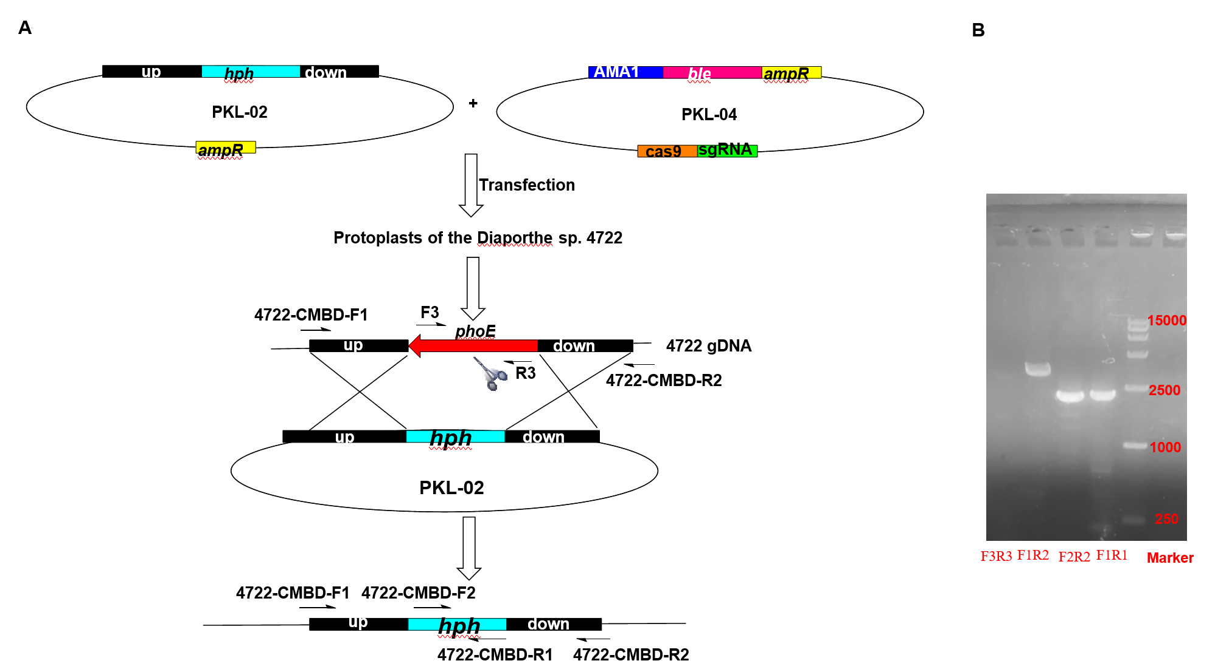

# **Figure S3**. Gene knockout of *phoE* in *Diaporthe* sp. SYSU-MS4722 in our previous wrok[1]. (A) The diagram of gene knockout of *phoE* and *hph* as the selective marker. (B) PCR analysis confirmed that the *phoE* was successfully disrupted.



**Figure S4**. Chiral separation of compounds **2** and **3** (Ultimate Amy-SR, MeCN/H2O = 15/85, flow rate = 3 mL/min)



**Figure** **S5.** LC-HRMS analysis comparing the production levels of compounds **1–3, 7**, and **8** in the wild-type and phoE mutant strains.



# **Figure S6**. 1H NMR spectrum for compound **1** (600 MHz, Methanol-*d*4)



# **Figure S7**. 13C NMR spectrum for compound **1** (150 MHz, Methanol-*d*4)



# **Figure S8**. HSQC spectrum for compound **1**



# **Figure S9**. HMBC spectrum for compound **1**



# **Figure S10**. 1H-1H COSY spectrum for compound **1**



# **Figure S11**. NOESY spectrum for compound **1**





# **Figure S12**. HR-ESI-MS spectrum for compound **1**



# **Figure S13**. 1H NMR spectrum for compound **2** (600 MHz, Methanol-*d*4)



# **Figure S14**. 13C NMR spectrum for compound **2** (150 MHz, Methanol-*d*4)



# **Figure S15**. HSQC spectrum for compound **2**



# **Figure S16**. HMBC spectrum for compound **2**



# **Figure S17**. NOESY spectrum for compound **2**





# **Figure S18**. HR-ESI-MS spectrum for compound **2**



# **Figure S19**. 1H NMR spectrum for compound **3** (600 MHz, Methanol-*d*4)



# **Figure S20**. 13C NMR spectrum for compound **3** (150 MHz, Methanol-*d*4)



# **Figure S21**. 1H-1H COSY spectrum for compound **3**



# **Figure S22**. HSQC spectrum for compound **3**



# **Figure S23**. HMBC spectrum for compound **3**





# **Figure S24**. HR-ESI-MS spectrum for compound **3**



# **Figure S25**. 1H NMR spectrum for compound **7** (600 MHz, Methanol-*d*4)



# **Figure S26**. 13C NMR spectrum for compound **7** (150 MHz, Methanol-*d*4)



# **Figure S27**. 1H-1H COSY spectrum for compound **7**



# **Figure S28**. HSQC spectrum for compound **7**



# **Figure S29**. HMBC spectrum for compound **7**



# **Figure S30**. NOESY spectrum for compound **7**

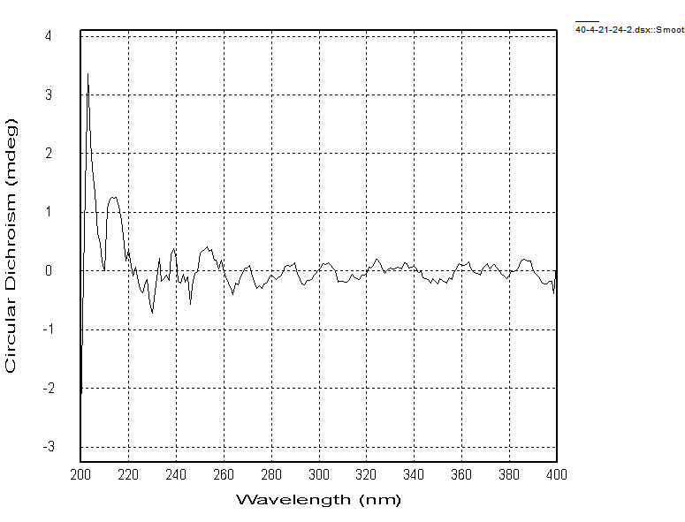

# **Figure S31**. ECD spectrum for compound **7**



# **Figure S32**. IR spectrum for compound **7**





# **Figure S33**. HR-ESI-MS spectrum for compound **7**



# **Figure S34**. 1H NMR spectrum for compound **8** (600 MHz, Methanol-*d*4)



# **Figure S35**. 13C NMR spectrum for compound **8** (150 MHz, Methanol-*d*4)



# **Figure S36**. HSQC spectrum for compound **8**



# **Figure S37**. HMBC spectrum for compound **8**



# **Figure S38**. 1H-1H COSY spectrum for compound **8**



# **Figure S39**. NOESY spectrum for compound **8**



# **Figure S40**. IR spectrum for compound **8**

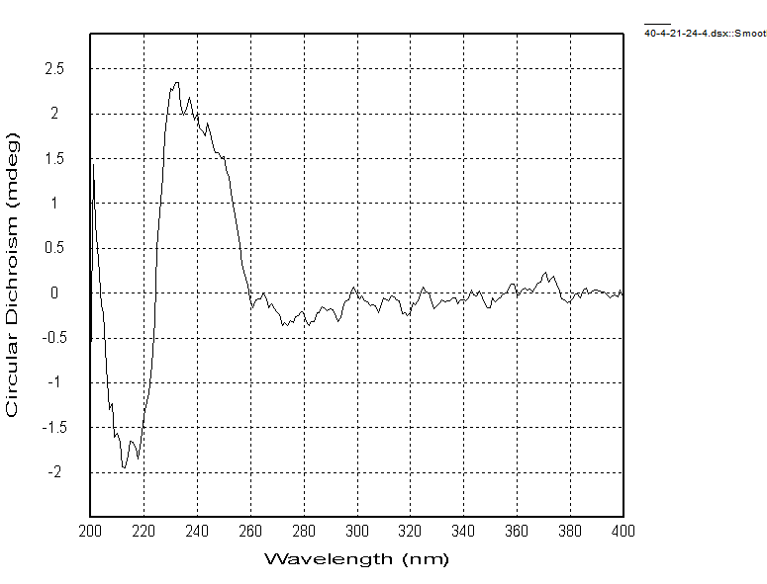

# **Figure S41**. IR spectrum for compound **8**





# **Figure S42**. HR-ESI-MS spectrum for compound **8**

# **Reference**

1. Yuan, S. W.; Chen, S. H.; Guo, H.; Chen, L. T.; Shen, H. J.; Liu, L.; Gao, Z. Z., Elucidation of the complete biosynthetic pathway of phomoxanthone A and identification of a para-para selective phenol coupling dimerase. *Org Lett.* **2022,** *24*, 3069-3074.

2. Zhai, G.; Chen, S.; Shen, H.; Guo, H.; Jiang, M.; Liu, L., Bioactive monoterpenes and polyketides from the ascidian-derived fungus *Diaporthe* sp. SYSU-MS4722. *Mar. Drugs* **2022,** *20*, 553.